Contributed by-

**AWS Project**

Amit Kumar Agrawal ([agrawal_amit_kumar@lilly.com](mailto:agrawal_amit_kumar@lilly.com))

Mallikarjun K ([k_mallikarjun@lilly.com](mailto:k_mallikarjun@lilly.com))

Rishi M K ([m_k_rishi@lilly.com](mailto:m_k_rishi@lilly.com))

Shashank B ([b_shashank@lilly.com](mailto:b_shashank@lilly.com))

1. **2 VPC Creation**

**Two VPC has been created with “area51-vpc1” and “area51-vpc2”.**

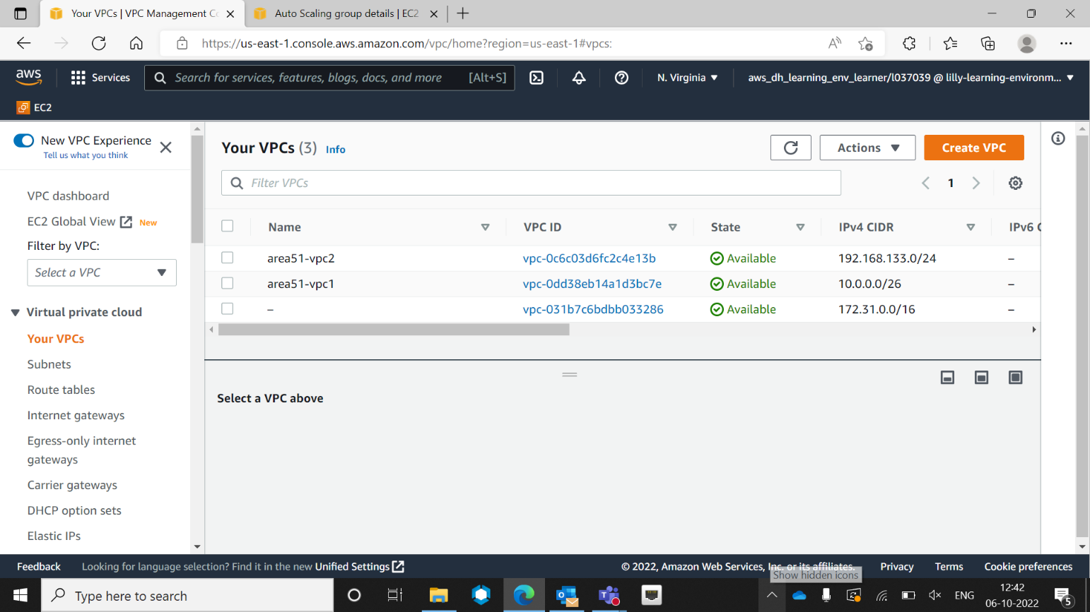

Screen captures of description of “area51-vpc1” with CIDR no. “10.0.0.0/26 ”, as we need to add 4 subnets in this VPC. Two should private and two should public.

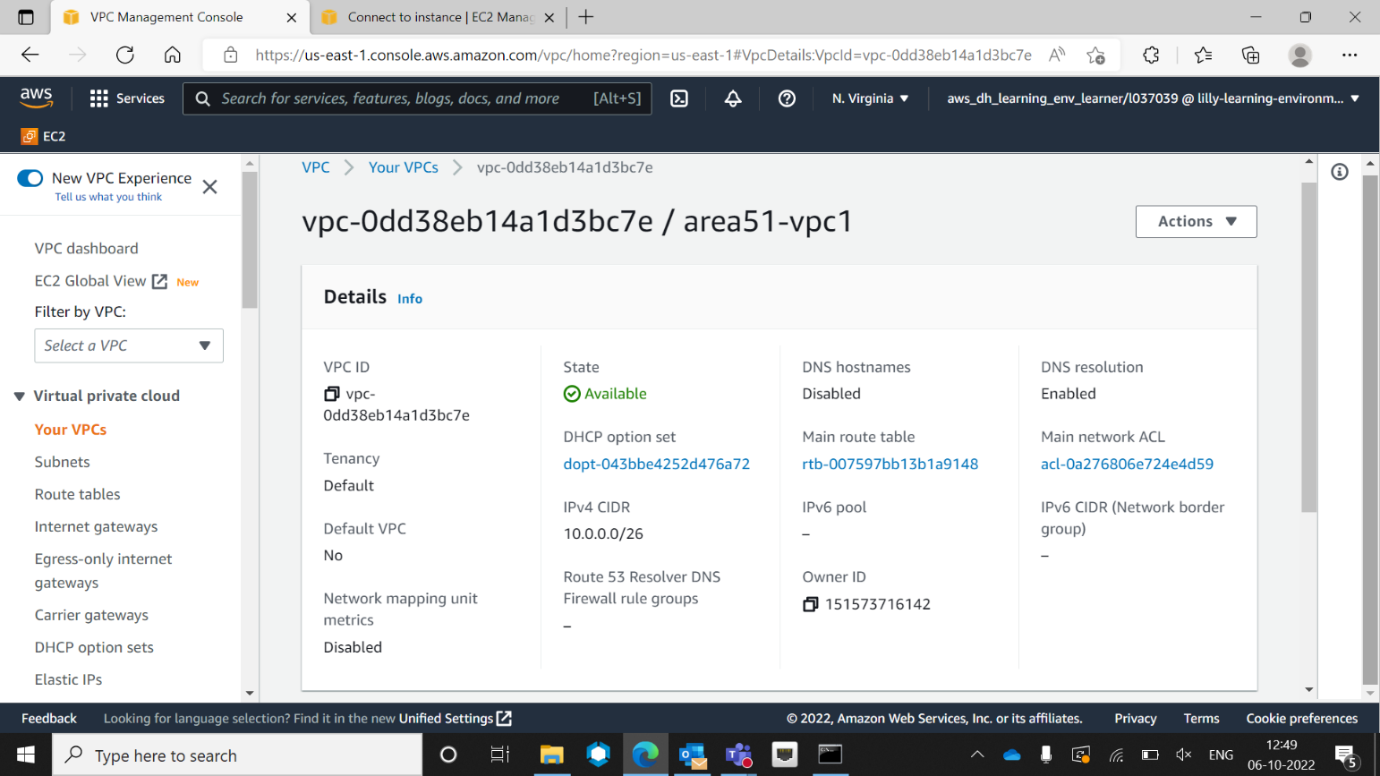

1. **Creation of autoscaling group.**

Auto Scaling Group has created with name “area51-group”

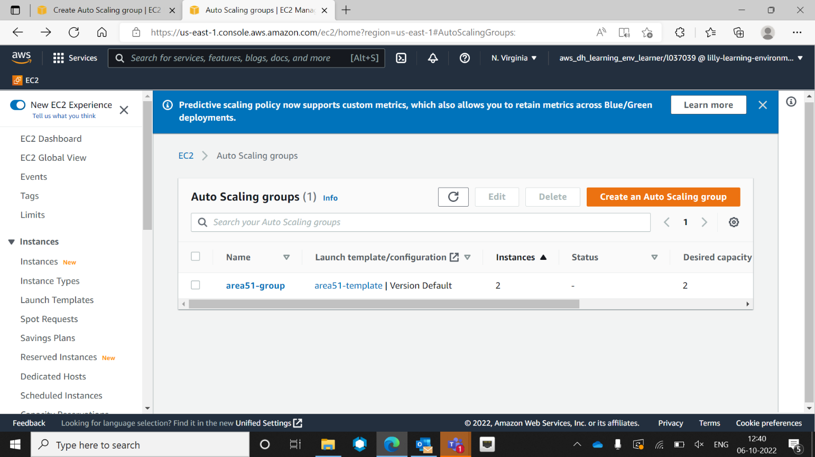

Details of auto scaling group “area51-group

1. **After creation of ec2- successfully, Connecting to Private ec-2 Lunix Machine.**

Logging to ec2- public, Lunix Machine with public IP “107.20.52.194”

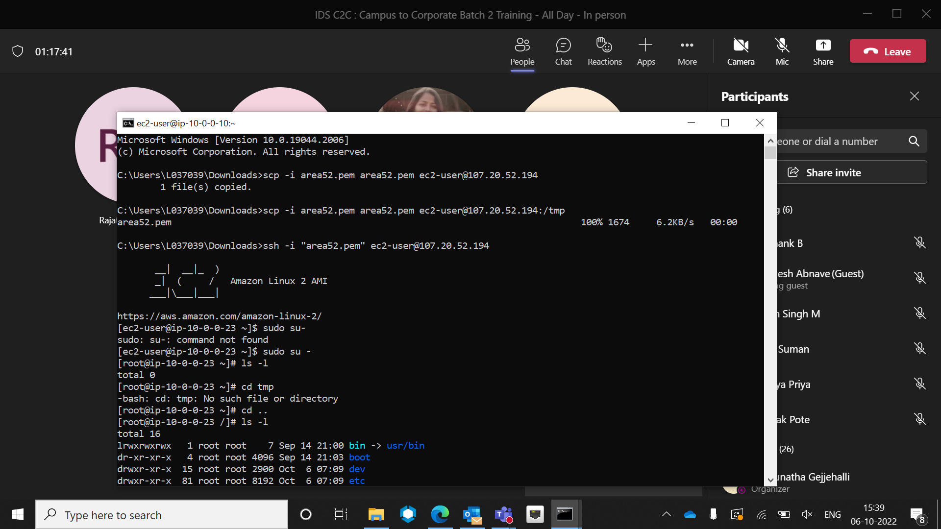

Logging to private ec2-Lunix Machine, with private IP address “10.0.0.10”

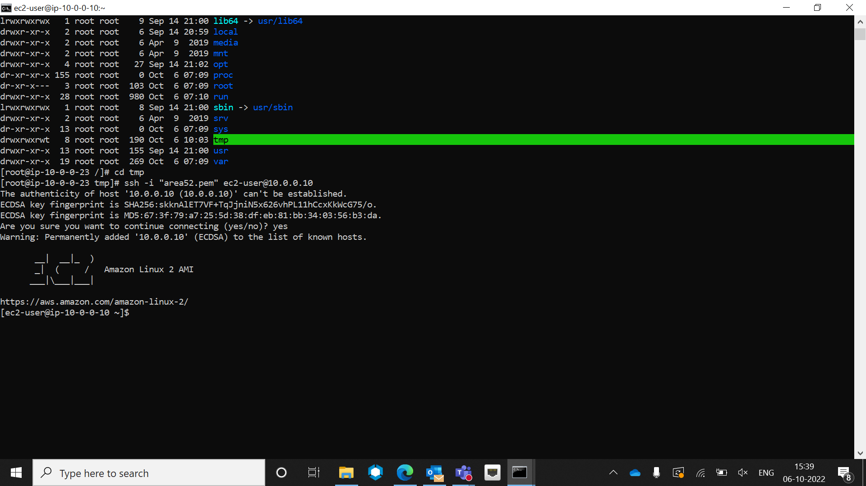

By pinging “google.com”, we can see NAT Gateway working successfully.

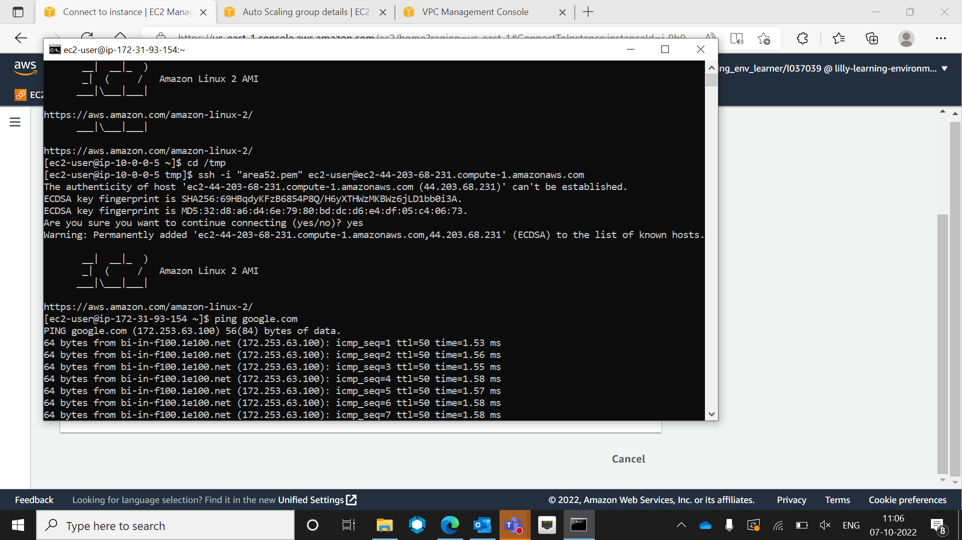

1. **Mounting of s3 bucket over ec2- Lunix Instance.**

We can see mounting of s3 bucket, say “vpc-project-1” done successfully inside “amit” folder of ec2- Instance.

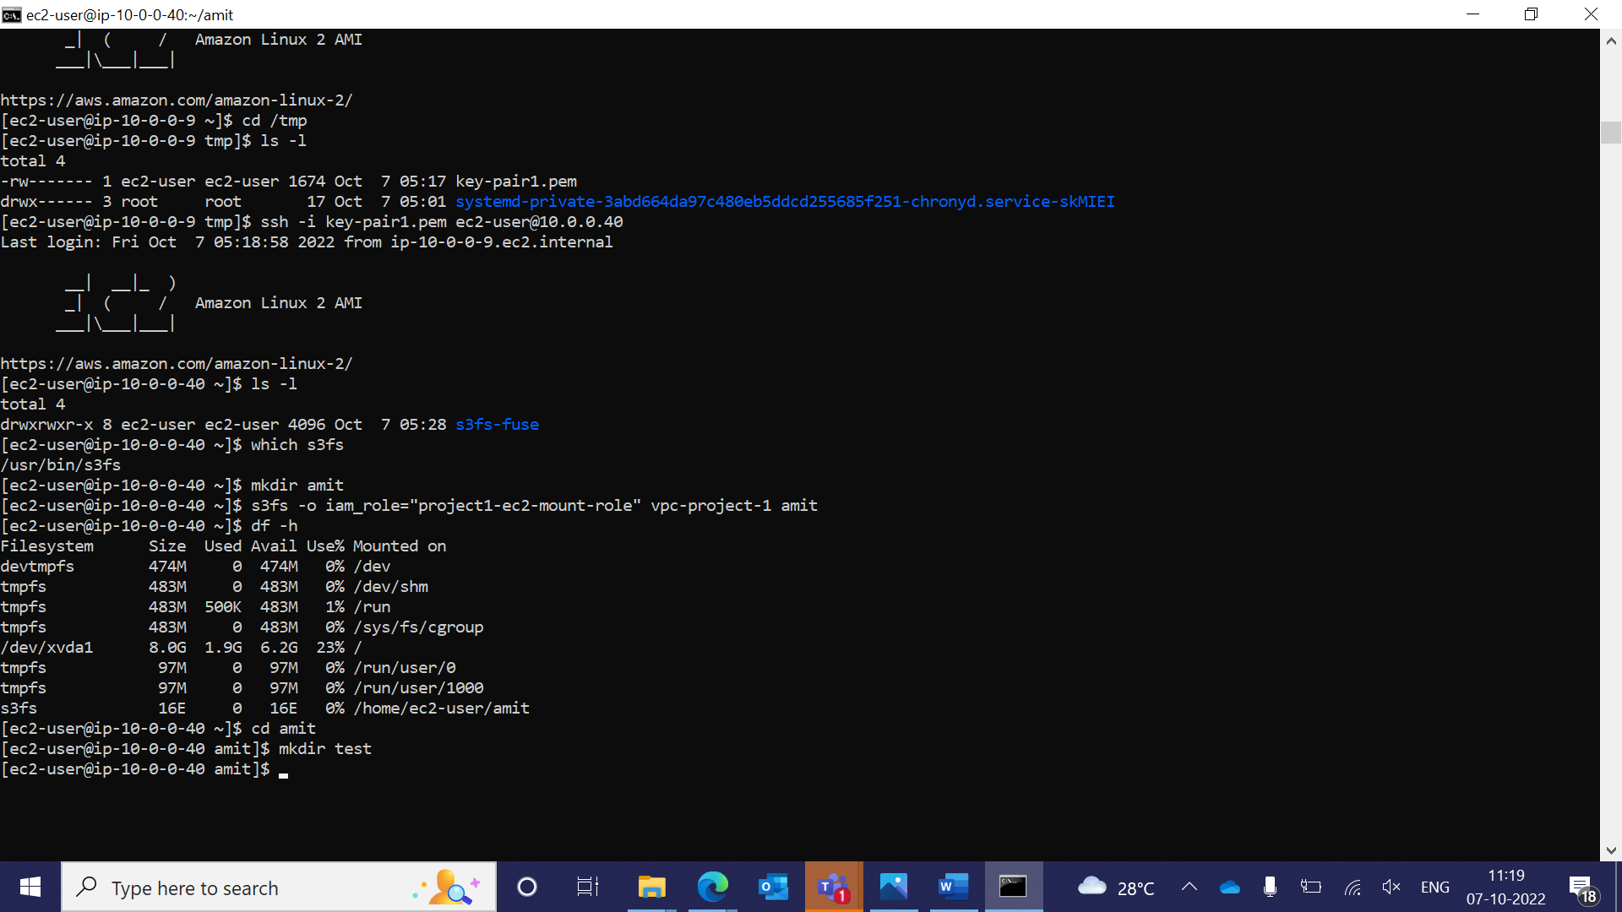

After mounting we are creating a folder in ec2-Instance, “ test” and we see that folder has been created successfully inside the “vpc-project-1” bucket.

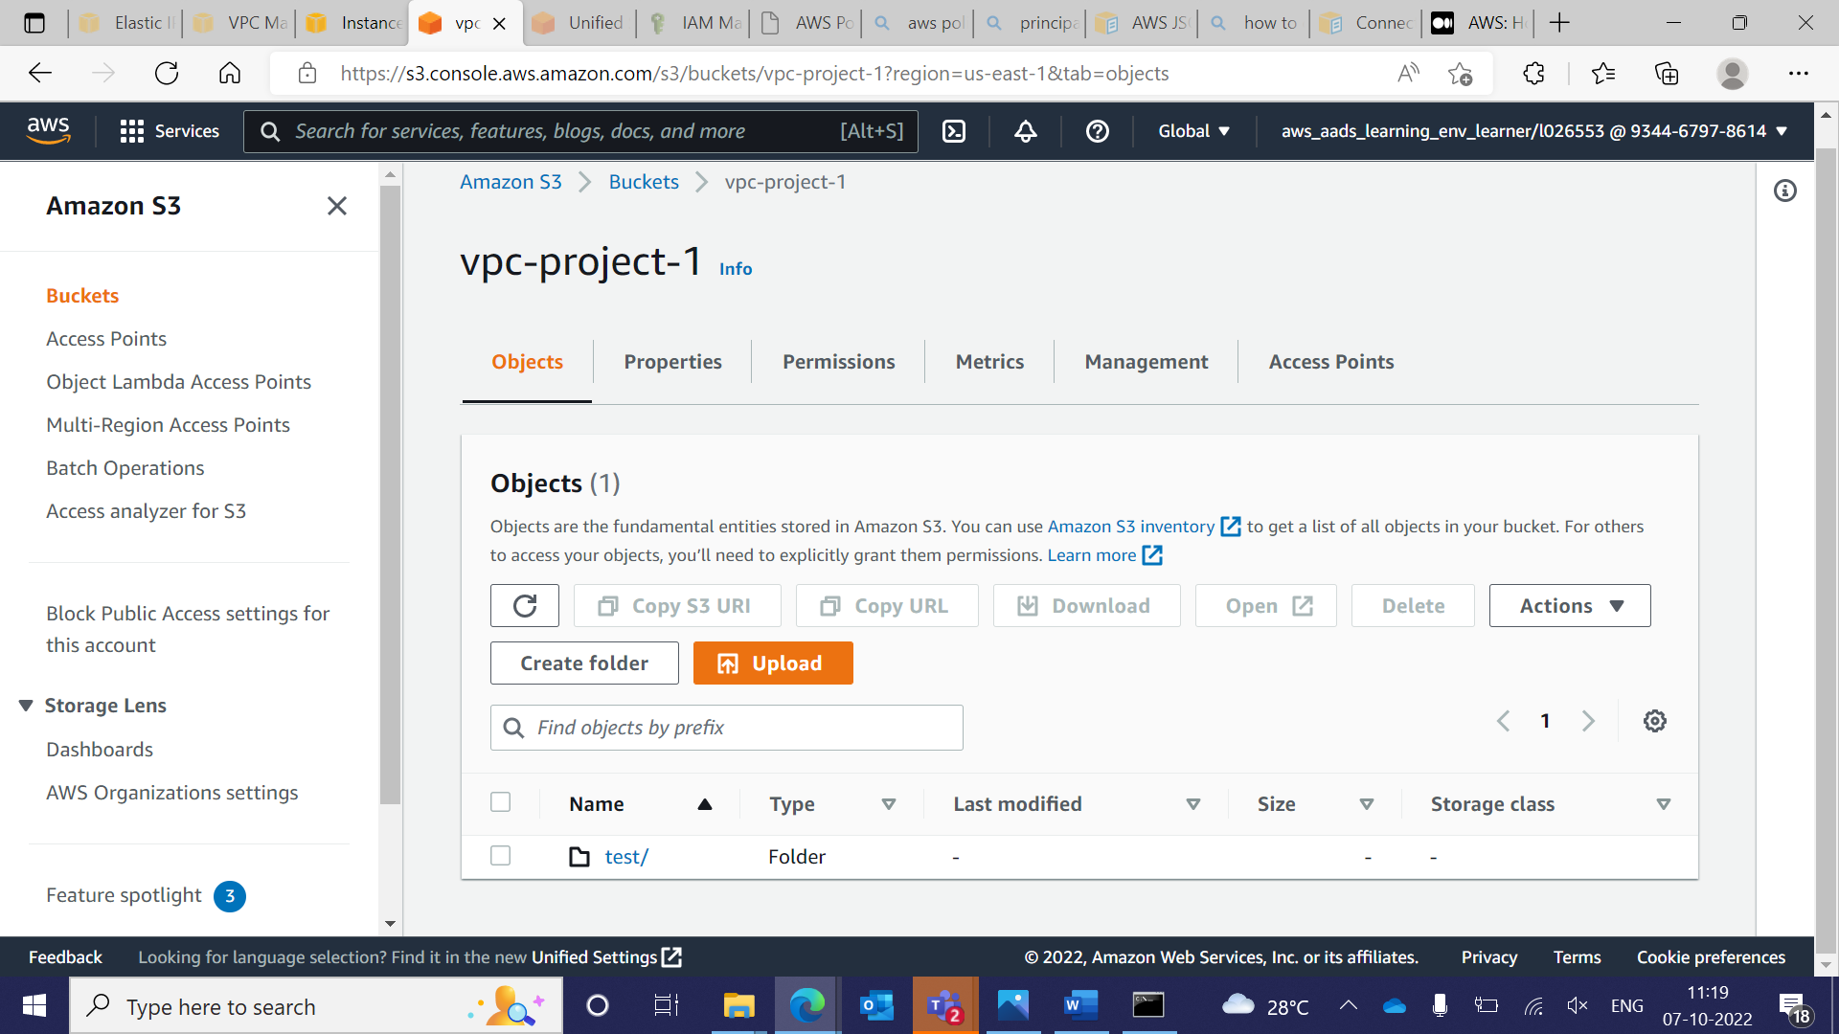

1. **Private RDS Creation and connecting through private ec2- Windows Instance.**

RDS Created with no publicly accessible.

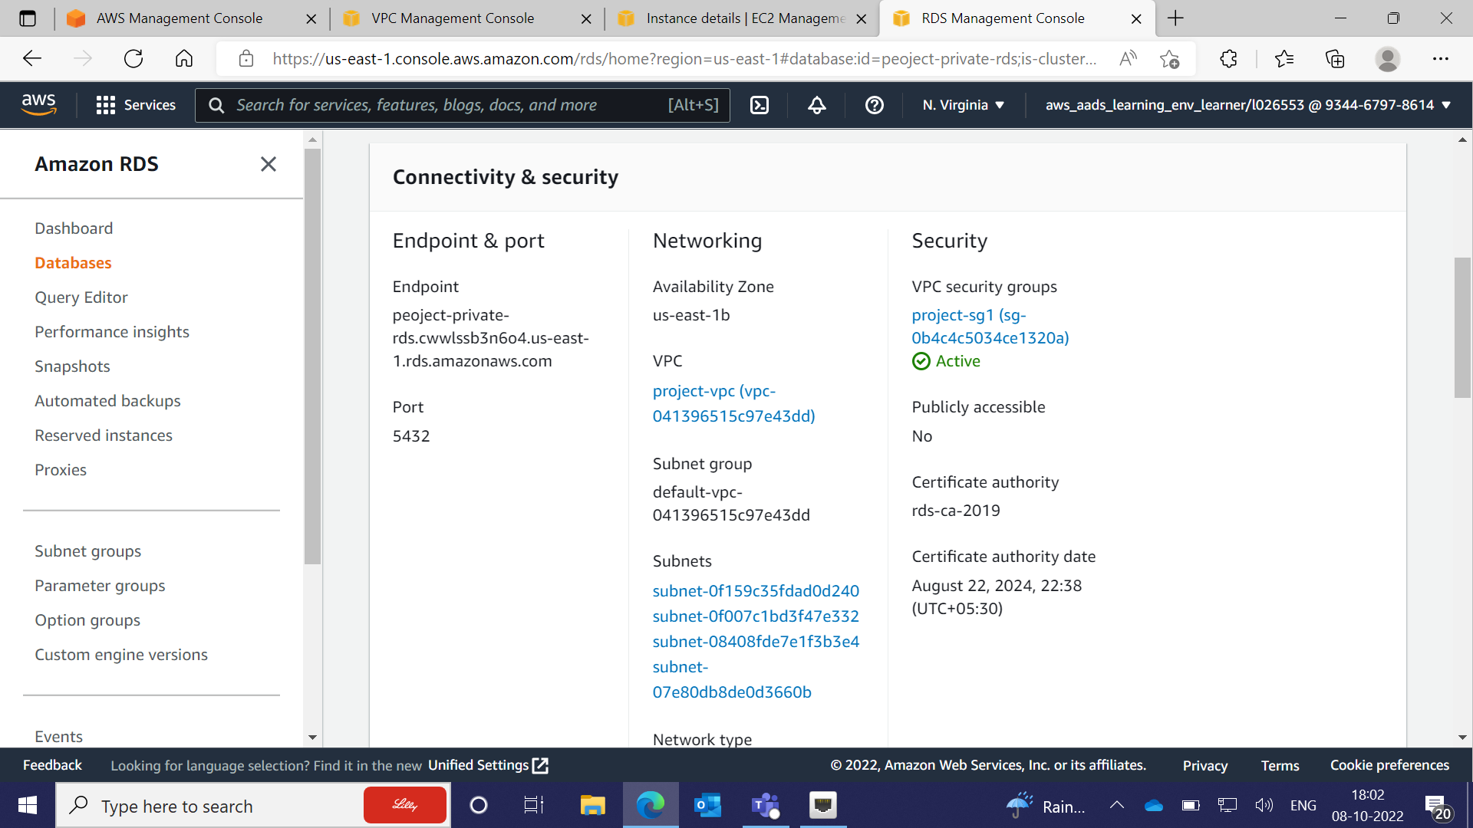

NAT Gateway created, connect private windows with internet, show that RDS could connect with private ec-2 Instance.

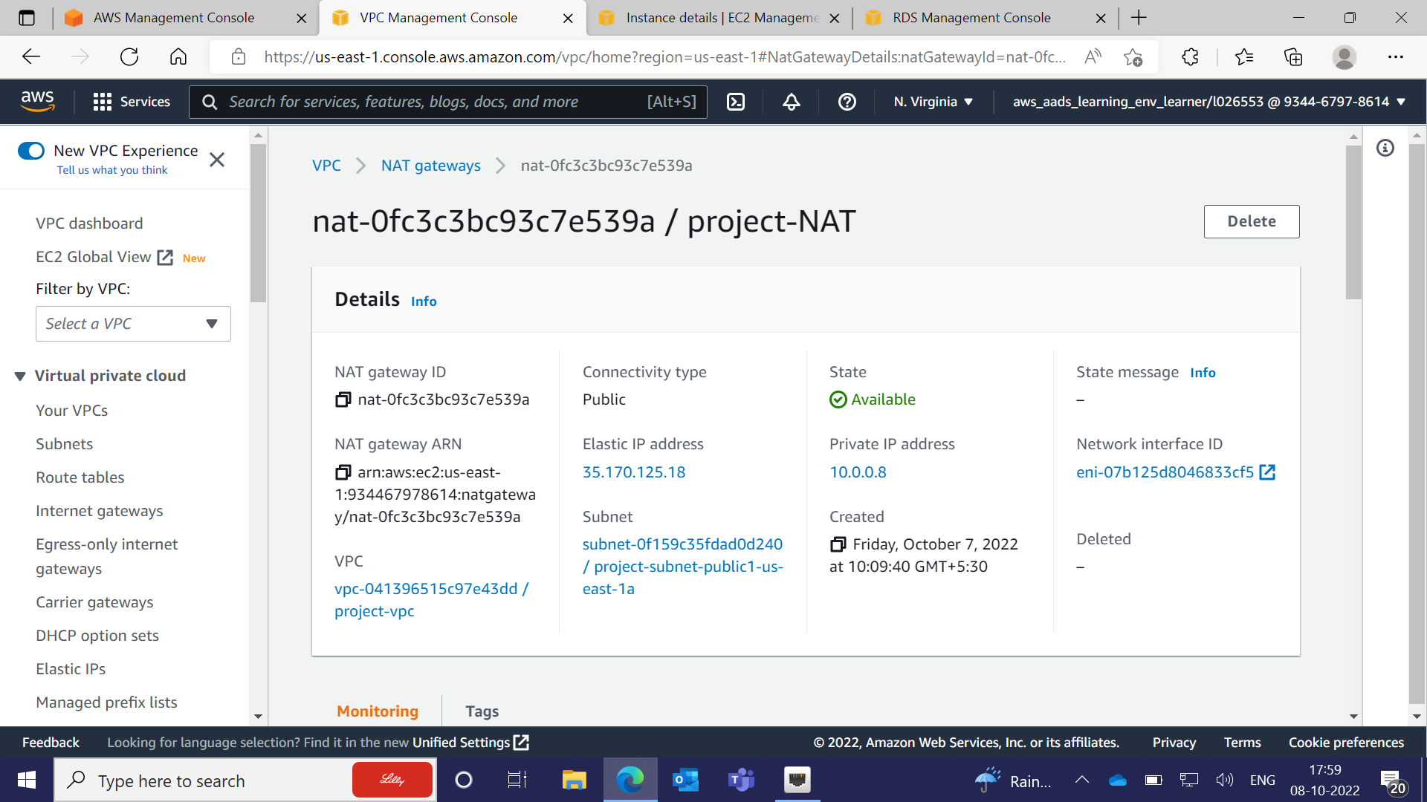

Public ec-2 Windows Instance connected successfully with Public IP 3.81.89.169 and Connecting Private ec-2 Instance.

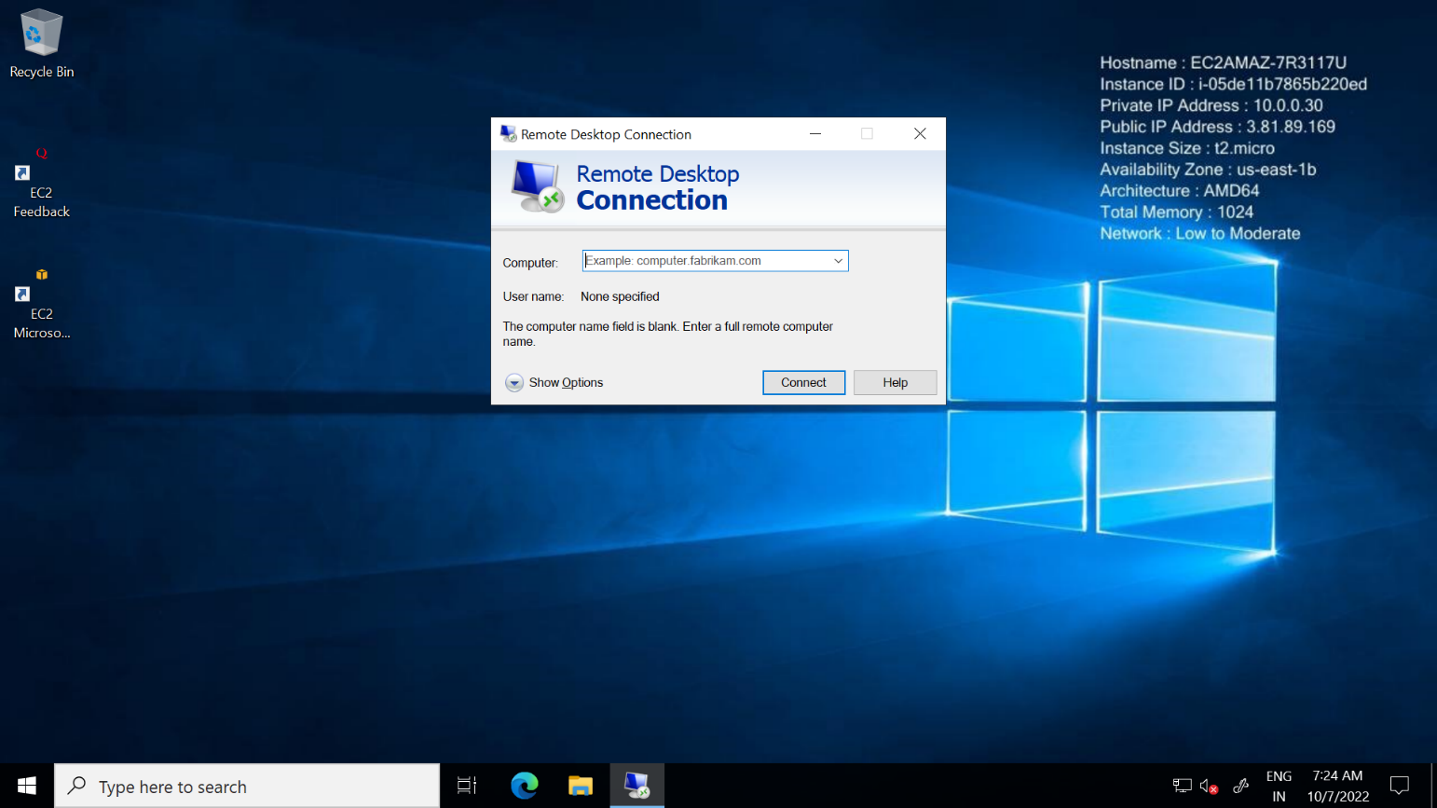

Private ec2- Windows Instance connected successfully with Private IP 10.0.0.59.

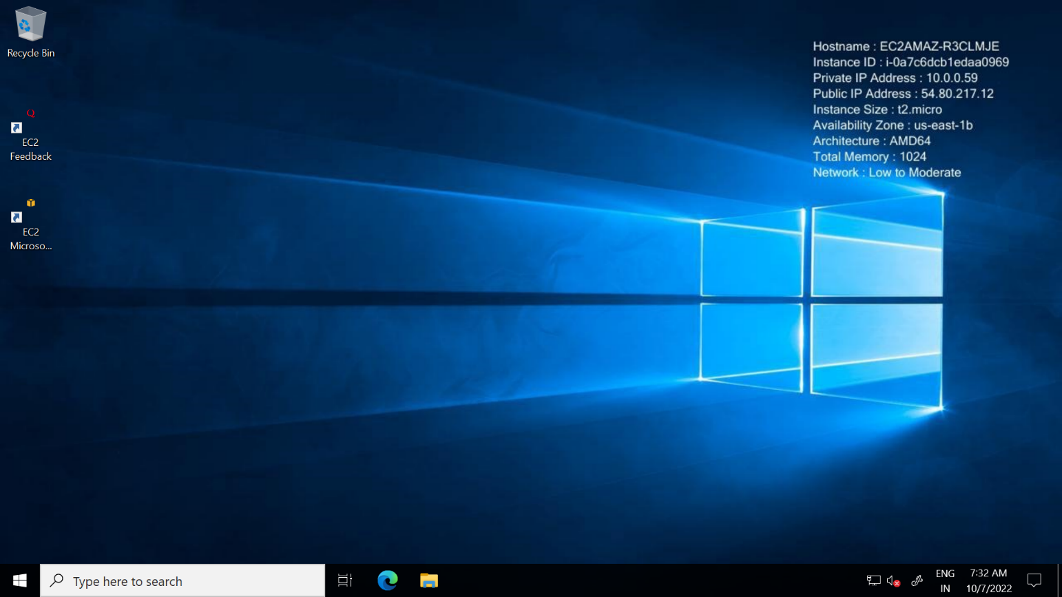

Installing PostgreSQL in private ec2-windows Instance, so that we connect RDS here.

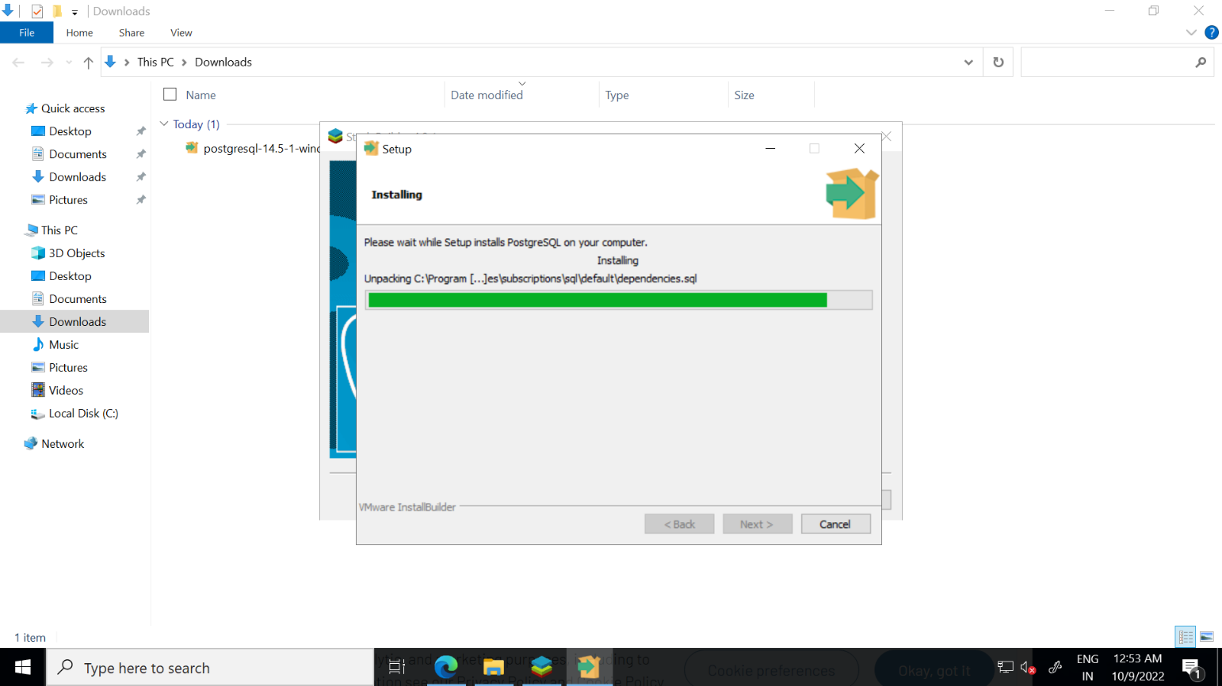

1. **2nd VPC created with only two Private Subnet, with purpose to connect with EFS.**

Two private subnets has been created, say “area51-subnet1” and “area51-subnet2” over the 2nd VPC “area51-vpc2”

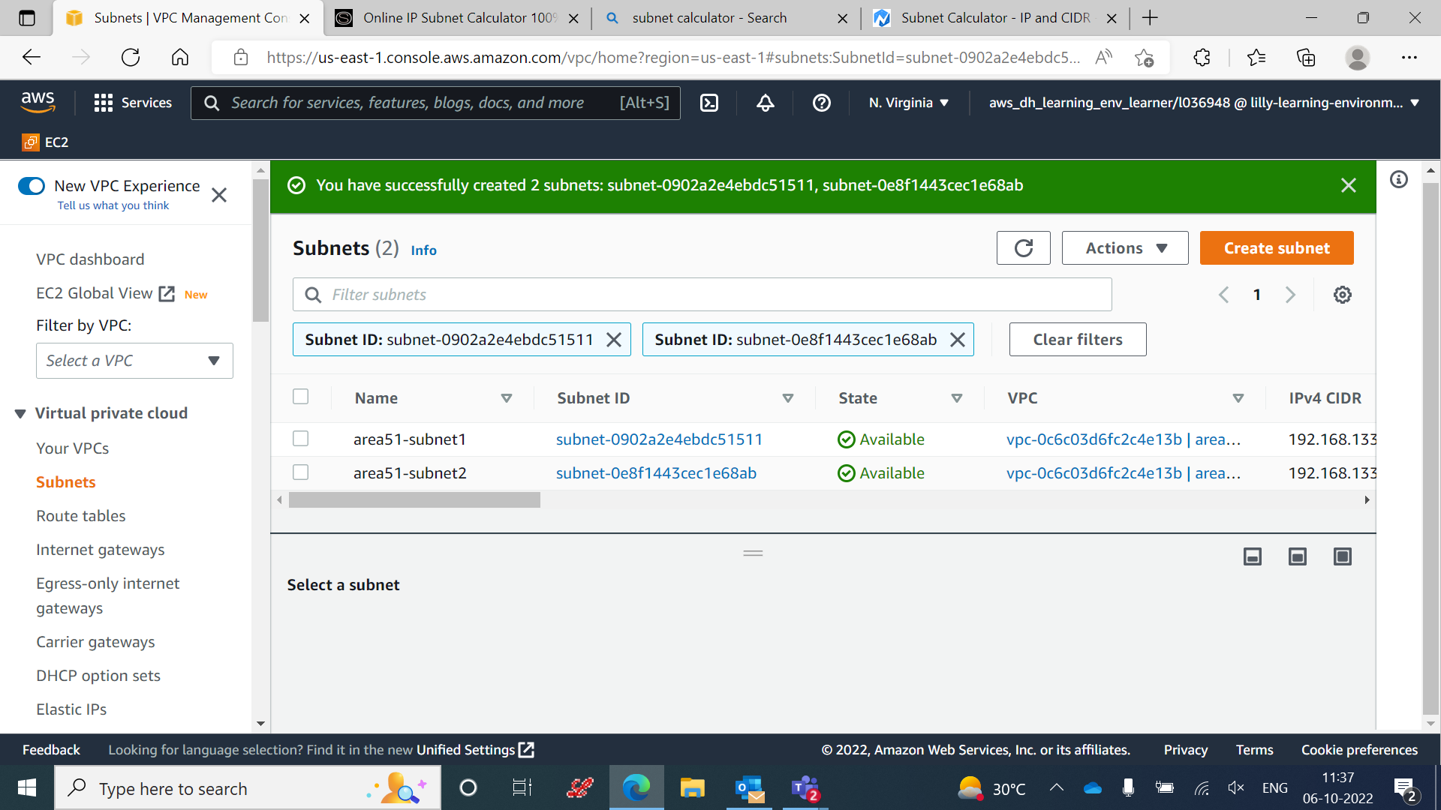

Instances “area51-ec-1” and “area51-ec-2” has been created over the subnets “area51-subnet1” and “area51-subnet2” respectively.

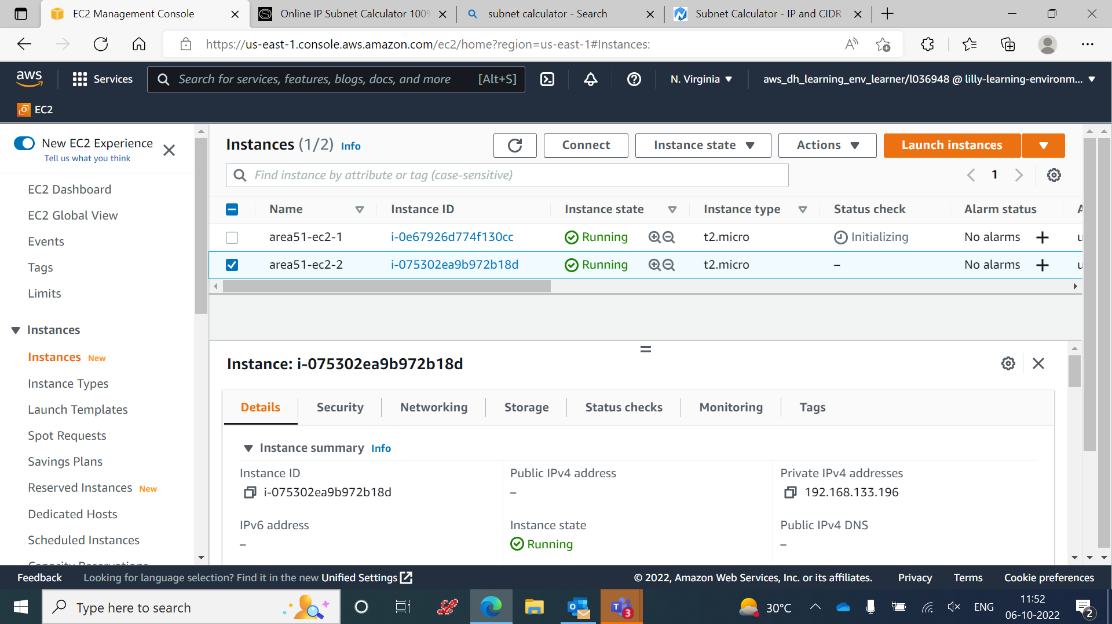

Route Table has been created to connect subnets “area51-subnet1” and “area51-subnet2” over the VPC “area51-vpc2”.

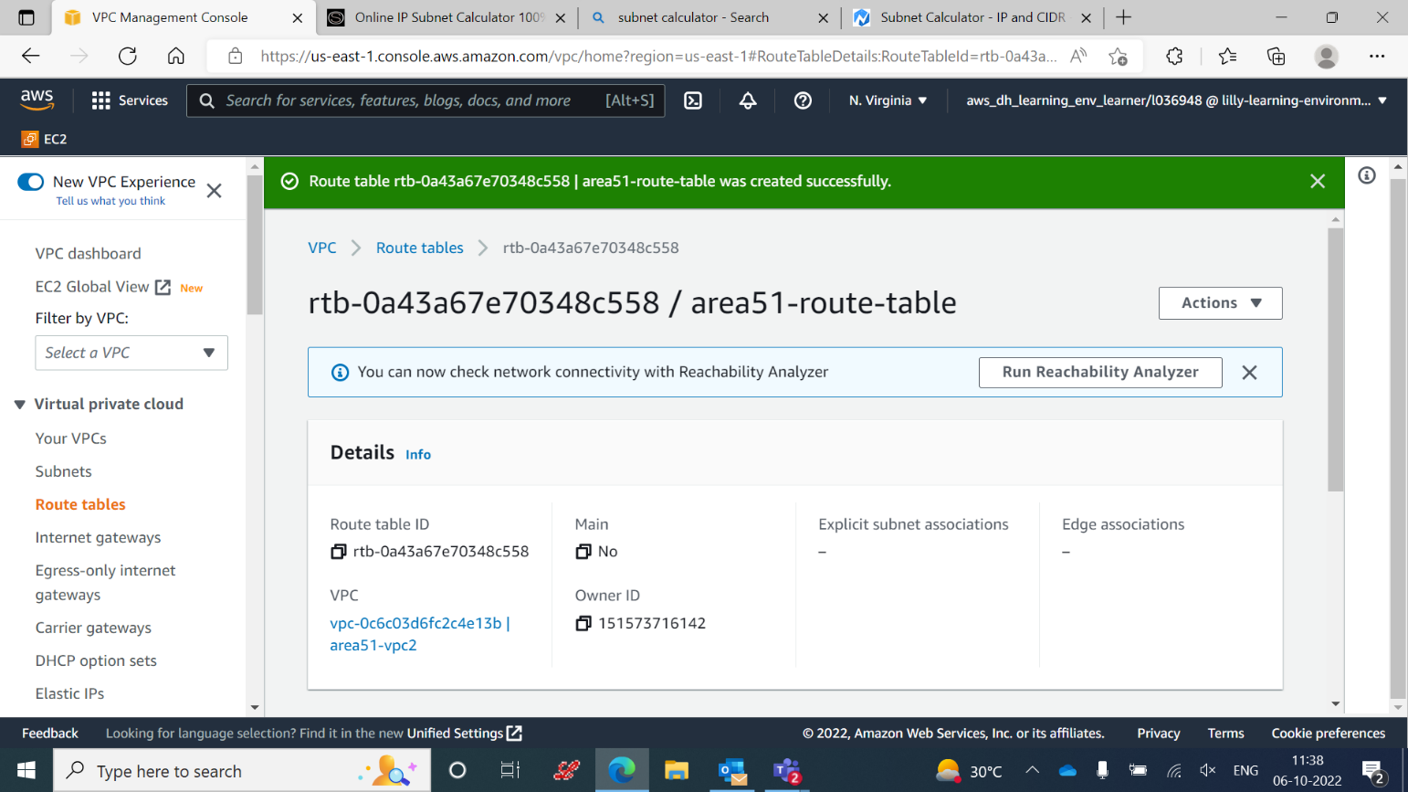

EFS has been attached successfully to with the Instance.

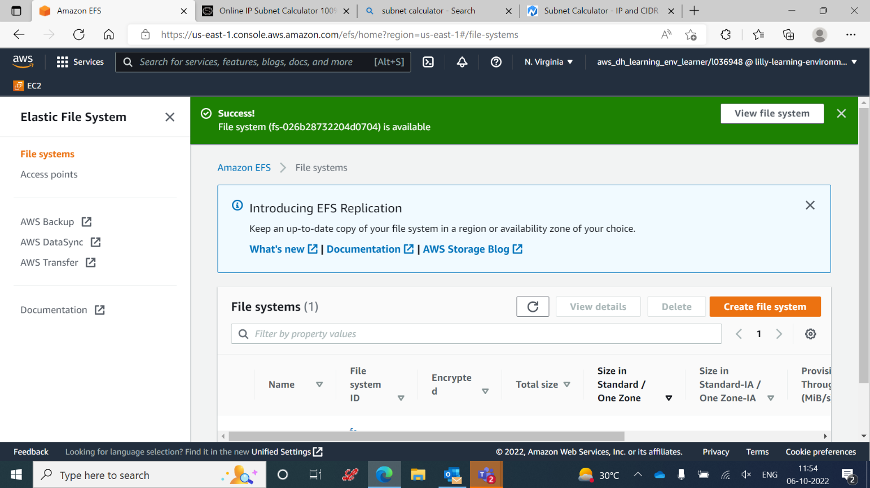

1. **Bucket creation to attach Event Notification SNS .**

Bucket has been created successfully.

SNS has been created successfully.

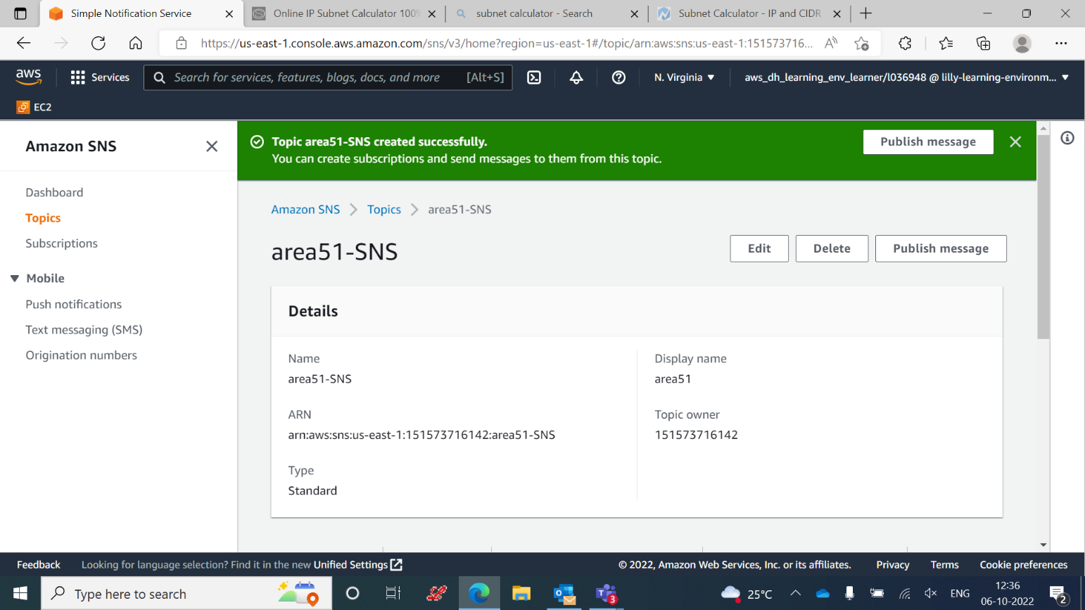

1. **Athena**

Athena connect successfully with Database.

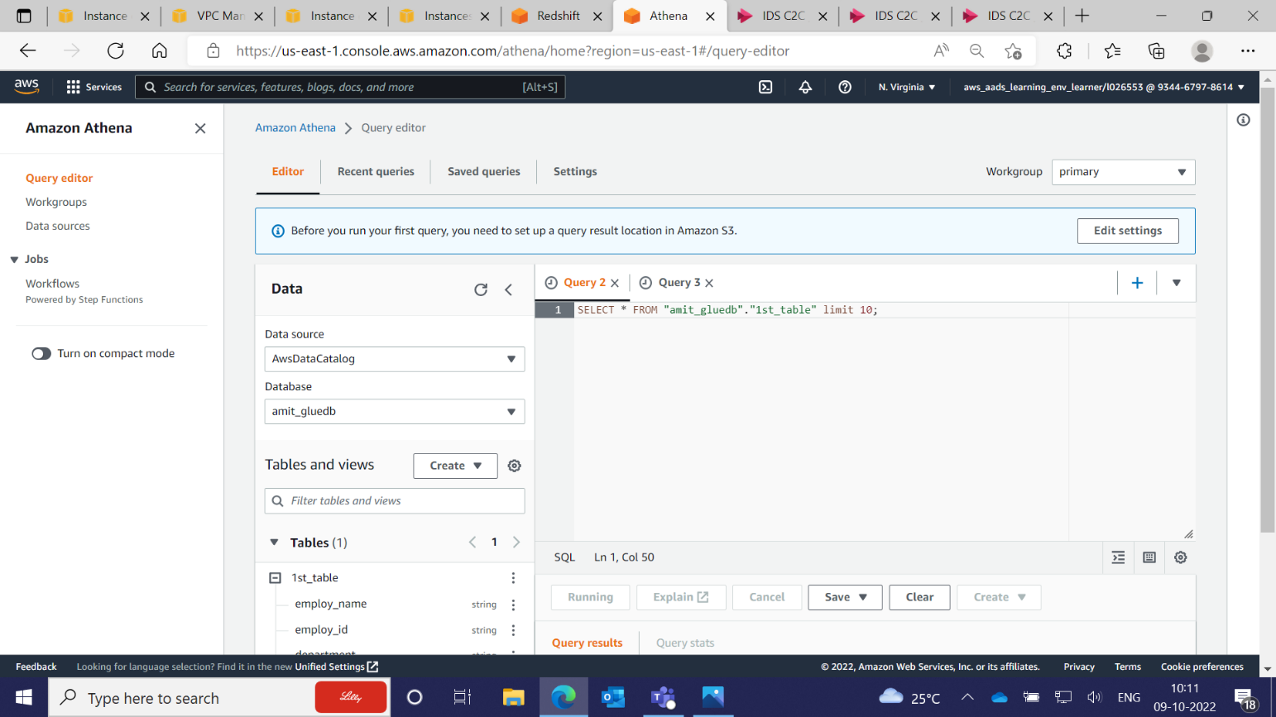

1. **Redshift**

Redshift also connected successfully.

